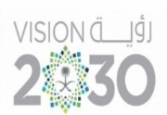**Kingdom of Saudi Arabia Tarbeat Al –Ajial International Schools**



**Ministry of Education American Section**

**Hafr Al Baten Directorate**

**2024/2025**

|  |  |  |  |
| --- | --- | --- | --- |
| **Student’s name** |  | **Grade** | **3** |
| **Subject** | **Computer** | **Week No.** | **2** |
| **Lesson Title** | **Inside a Computer** | **1st Semester Work sheet No.** | **2** |

**Instruction: Match the following according to their usage.**

|  |  |
| --- | --- |
|  | **VIDEO CARD** |
|  | **LAPTOP BATTERY** |
|  | **CENTRAL PROCESSING UNIT** |
|  | **EXTERNAL DISC** |
|  | **POWER SUPPLY** |